*Access to Water as a Human Right*

Clean Water: The Struggle for Environmental Justice in Flint and Standing Rock

Gabriella Wilson

[Wilsong2@montclair.edu](mailto:Wilsong2@montclair.edu)

May 8, 2017

**Lesson Plan**

**Unit Topic:** *Access to Water as a Human Right*

**Lesson:** Clean Water: The Struggle for Environmental Justice in Flint and Standing Rock

**Rationale for the Lesson:** At the end of the lesson students should recognize all the ways their own lives would be effected without access to water. They will think critically about the definitions of environmental racism and environmental justice. Students will understand the institutionalized racism that exists in the fight for access to water. Students will also be able to point out the differences between the stereotypical narrative on access to water and the narrative they learned in the lesson plan.

**Standards: Grades 9-10 ELA Common Core: History/ Social Studies**

* **RH.9-10.7:** Integrate quantitative or technical analysis with qualitative analysis in print or digital text
* **RH.9-10.9:** Compare and contrast treatments of the same topic in several primary and secondary sources
* **RH.9-10.4:** Determine the meaning of words and phrases as they are used in a text, including vocabulary describing political, social, or economic aspects of history/ social science
* **RH.9-10.2:** Determine the central ideas or information of a primary or secondary source; provide an accurate summary of how key events or ideas develop over the course of the text.
* **RH.9-10.3:** Analyze in detail a series of events described in a text; determine whether earlier events caused later ones or simply preceded them

**Essential Question/Guiding Question:** *What is environmental racism? Why is access to water a human rights issue? What are examples of environmental racism in the United States, in terms of access to clean water, and what is being done about it?*

**Objectives:**

* **SWBAT** recognize and think critically about environmental racism and environmental justice.
* **SWBAT** think critically about the human right to water and take a position on the adequate standard of living.
* **SWBAT** recognize and think critically about the Flint Michigan water crisis and the Dakota Access Pipeline and why they relate to environmental racism.

**Lesson Opener/Anticipatory Set/Lead-In/Do Now: 2 min.** Students will produce a list of all the things that they use water for. Students will then write on the board some of the examples from their lists. Define and explain how access to clean water is a human rights issue globally and in the US.

**Step-By-Step Procedures with Time Allocations:**

* **5 min.** A PowerPoint presentation with an overview on water as a human right issue
* **5 min.** Two videos on environmental racism and environmental justice
  + Students will be asked to write down the definitions of what they think environmental racism and environmental justice mean before-hand and then during the video they will write a second definition based on what they learned. I will then ask students to share out loud what was different between their original definitions and the ones I shared.
* **10 min. Case Study 1: DAPL**
  + Introduce DAPL—handout timelines of events.
  + Hand out 2 newspaper articles one FOR DAPL one AGAINST DAPL. Ask students to read both and make a list of the best arguments for and against building the pipeline.
  + Share in pairs. Discuss as class.
* **10 min. Case Study 2: Flint, Michigan** 
  + Introduce Flint—handout timeline of events.
  + Hand out 2 newspaper articles one saying systematic racism played a role in Flint and one saying systematic racism did not play a role in Flint. Ask students to read both and make a list of the best arguments for and against building the pipeline.
  + Share in pairs. Discuss as class.
* **10 min.** Students will be shown a picture and a poem. Students will discuss how this picture represents what they are taught about access to water in regards to the case studies they just looked at and discussed and how it compares to the poem given. This will compare the typical access to water narrative (picture) with the modern access to water narrative (poem).We will write a Venn diagram on the board in order to compare and contrast

**Lesson Closure:**

* **5 min.** Students will be asked to open up their discussions to the entire classroom. Students will also have time to ask questions about access to water.

**Materials and Equipment Needed:**

* Power Point
* Video
* Handouts
* Pictures

**Assignment:**

* Students will take the picture and poem they are shown and develop a chart that showcases the point-counter-point differences in the stereotypical access to water narrative and the modern access to water narrative they just learned about.

**Assessment: (how will I evaluate student learning?)**

* Evaluations will be made based off the assignment at the end of the lesson. Students should be able to identify the differences between the two narratives and think critically about the reasons access to water is a human rights issue.
* Evaluations based on
  + Students discussions and charts on access to water narratives
  + The relationships that students draw pertaining to access to water
  + Students ability to assess environmental justice and racism

**Modifications for diverse learners (how does this lesson make accommodations?)**

* This lesson plan incorporates both lecture and break out groups in order to accommodate all learners.
  + Video
  + Pictures
  + Lecture
  + Discussion groups
* I will walk around the classroom listening to student’s discussions, ensuring there is no confusion or uncertainty, and answering questions when needed.

Protests at the Dakota Access Pipeline (DAPL) still haven’t subsided, and for good reason – this is a fight the American people, particularly the indigenous American people, can’t afford to lose.

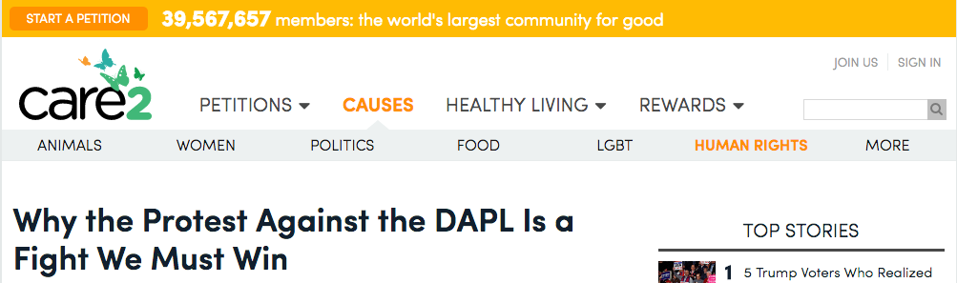

**What’s Going on in North Dakota?**

In case you’re behind on the details, Care2 has covered the DAPL saga in the preceding months, starting when Native Americans were [first forbidden from protesting](http://www.care2.com/causes/why-have-native-americans-been-banned-from-protesting-an-oil-pipeline.html) the construction on their own land. Protests continued, however, and pipeline security [brutally attacked](http://www.care2.com/causes/pipeline-crew-attacks-native-american-protesters-with-dogs-and-pepper-spray.html) the activists.

Last month, a federal court ruled that the DAPL had the [legal right to continue](http://www.care2.com/causes/federal-court-allows-dakota-access-pipeline-to-move-forward.html) construction. Though he initially encouraged construction to be halted, President Obama has [not weighed in publicly](http://time.com/4548566/dakota-access-pipeline-standing-rock-sioux/) on the DAPL since the federal court ruling.

Now, the pipeline construction company is rapidly moving forward with the project – presumably before any officials change their mind. The Standing Rock Sioux tribe and greater community are not backing down from trying to halt construction, though, with protests in full force.

Last Thursday, police [arrested over 140 activists](https://mic.com/articles/157918/more-than-100-dapl-protestors-arrested-after-clash-with-police#.QdC2naRxY) for impeding construction. Police shot rubber bullets and pepper spray at the protesters; arrestees were, no joke, [locked in dog kennels](http://www.latimes.com/nation/la-na-north-dakota-pipeline-20161028-story.html) for hours.

The local authorities say these measures were necessary since the crowd grew violent, but protesters said it was the police who acted aggressively. The protesters even stopped one guy they thought to be on their side with a rifle – they later discovered that this guy was [employed by the pipeline’s security team](http://www.democracynow.org/2016/10/31/did_dapl_security_worker_wielding_an) and was trying to make the protesters look bad.

Top of Form

Bottom of Form**Why This Fight Matters**

It’s clear that the protesters are not going down without a major fight. We owe our native communities so much gratitude for committing themselves to safeguarding the environment. Beyond that, though, we also owe the native peoples the right to be acknowledged and respected by the government, as well as the right to just exist.

As Indigenous writer Kelly Hayes writes in [an essay for Yes! Magazine](http://www.yesmagazine.org/how-to-talk-about-standing-rock-20161028), “Standing Rock is part of an ongoing struggle against colonial violence.” Dominant white society has relegated Native Americans to the margins, while continuing to take what it wants from them whenever it wants it.

Non-indigenous culture tends to think of Native Americans from a purely historical perspective rather than considering their existence in the present. To this day, tribes struggle to maintain both their land and their rights, though these battles seldom are heard in the mainstream media.

Tribes from across the country have united in almost unprecedented fashion to stand up against the DAPL. As much as this is about protecting the environment, this protest has probably even more so become about not allowing the U.S. government to push around Native Americans anymore.

Remember – the Standing Rock tribe, whose sacred land and waterways this pipeline would cross through, was never properly consulted before construction began.

It’s also important to note that an alternative route had been considered for the DAPL, but was ultimately rejected in part because it crossed through the Missouri River near [where the city of Bismarck gets its water](http://bismarcktribune.com/news/state-and-regional/pipeline-route-plan-first-called-for-crossing-north-of-bismarck/article_64d053e4-8a1a-5198-a1dd-498d386c933c.html). The message couldn’t be any clearer: why put the pollution risk on white people when we can pass it off to Native Americans instead?

The tribes cannot back down from a fight like this – nor should they.

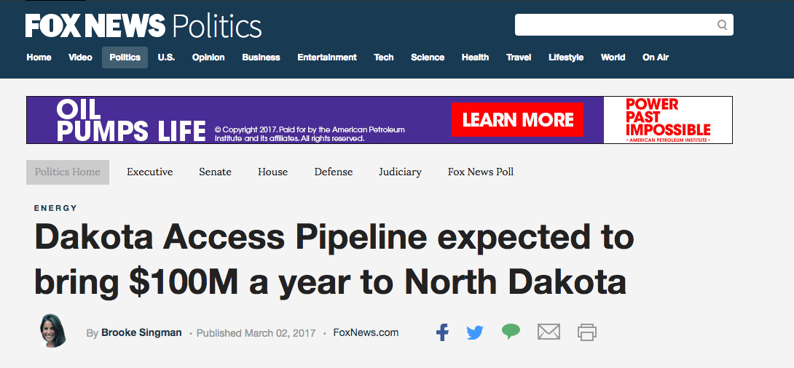

North Dakota is expected to gain $100 million or more annually in tax revenue once crude oil begins flowing through the Dakota Access Pipeline, according to an Associated Press report released on Thursday.

That’s money the sparsely populated northern state, which struggles with declining tax revenue, can use.

North Dakota has a police bill of $33 million from the cost of dispatching officers and security personnel to the pipeline site to respond to sometimes violent protests.

As soon as next week, Dallas-based Energy Transfer Partners’ $3.8 billion pipeline could begin shipping crude oil on the more-than 1,000-mile journey to Illinois.

North Dakota gains tax revenue from every barrel of crude that flows through the pipeline. Besides oil tax revenue from the pipeline, the state can expect more than $10 million annually in property taxes related to the pipeline.

North Dakota’s state budget analysts expect to release a new revenue forecast next week that reflects the anticipated tax revenue increase, said State Budget Director Pam Sharp.

While the revenue the state expects to gather in just one year will far exceed North Dakota's higher police expenses, experts say the extra revenue shouldn’t be considered a payoff.

“This is just one benefit a state gets if it is able to make these pipelines work,” Nick Loris, research fellow in energy and environment policy at the Heritage Foundation, told Fox News. “It’s a cherry on top economically, for something that gets Americans and businesses reliable, safe sources of energy — these are good things.”

But Fox News contributor and former Rep. Dennis Kucinich, D-Ohio, who opposes the pipeline, said the real cost may be higher than state officials know.

“North Dakota and other states may soon discover that the temporary financial benefits of pipeline revenue will be far outweighed by the almost incalculable environmental damage which these pipelines bring, including the potential contamination of drinking water supplies,” Kucinich told Fox News.

WASHINGTON — [The contaminated water](http://www.huffingtonpost.com/entry/flint-michigan-water-lead_us_568be5abe4b014efe0dbb159) disaster flowing through one of Michigan’s poorest, blackest cities is tainted by poverty and racism.

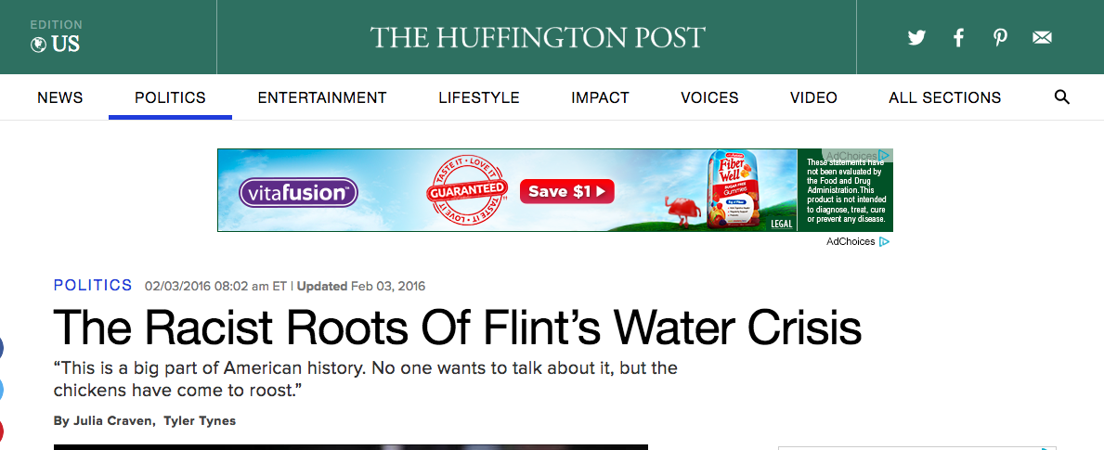

Since April 2014, residents of Flint, a city that is almost [57 percent black and incredibly poor](http://quickfacts.census.gov/qfd/states/26/2629000.html), have been drinking and bathing in water that contains enough lead to meet the Environmental Protection Agency’s definition of “[toxic waste](https://www.washingtonpost.com/news/wonk/wp/2016/01/15/this-is-how-toxic-flints-water-really-is/).”

No single person shoulders the blame for this situation, but thanks to widespread mismanagement a largely black and brown community now faces the disproportionate effects of systemic neglect. And to many, Flint’s water crisis fits into a historical trend of [environmental racism](http://weavenews.org/blogs/cmalex10/2526/environmental-racism-works#comment-2545) in the U.S., which for [decades](http://www.huffingtonpost.com/entry/flint-water-crisis-minorities-environmental-justice_us_56afc907e4b057d7d7c7ce27?d9fqolxr) has allowed polluters to prey on communities of color, in part because of weak environmental regulations.

“There’s a philosophy of government that has been writing these places off — places like Flint get written off,” Flint’s Rep. Dan Kildee (D-Mich.) told The Huffington Post. “And, to me, even though those people making those decisions might not see it this way, it’s hard for me to accept the fact that race is not the most significant factor.”

At the first democratic presidential debate of the year, Hillary Clinton issued a rallying cry for Flint’s predicament, saying that the crisis would have been handled differently if it happened in a “[white suburb outside of Detroit](http://www.huffingtonpost.com/entry/democratic-debate-flint-water_us_569c62dae4b0b4eb759ed6da).”

While [state offices](http://www.huffingtonpost.com/entry/rick-snyder-flint_us_56a10daae4b076aadcc579b0) and [presidential candidates](http://www.huffingtonpost.com/entry/jeb-bush-rick-snyder-flint-water_us_56a4e271e4b0d8cc109a6324) have rushed to criticize Michigan’s handling of the Flint water crisis, the legacy of environmental injustice and racism in the once-thriving city stretches far beyond lead pipes and discolored tap water.

In 1966, Flint’s automotive industry was booming. [Buick City](https://www.wsws.org/en/articles/1999/07/auto-j02.html), a 235-acre factory that produced Buicks for General Motors, churned out thick clouds of smoke, which floated over Flint’s poverty-stricken, predominantly black North End neighborhood.

At a state Civil Rights Commission hearing on the environmental impact of the plant, which opened in 1904, North End resident Aliene Butler [testified](http://www.latimes.com/opinion/op-ed/la-oe-0131-highsmith-flint-water-crisis-20160131-story.html) to the horrid conditions residents faced.

“The houses in this district are eaten up by a very heavy deposit, something like rust,” she said. “You can imagine what we go through down there breathing when this exists on just material things.”

Butler, a throat cancer survivor who lost her husband to the same illness, had highlighted one way de facto segregation leads to environmental injustice.

That same year, Buick City dumped [2.2 million gallons of waste per day](http://nepis.epa.gov/Exe/ZyPDF.cgi/9100LFR4.PDF?Dockey=9100LFR4.PDF) into the Flint River. The year before, the eight GM plants around Flint had dumped about 26.5 million gallons of industrial waste into the river each day.

The city used the Flint River for its water supply [until 1967](https://www.michigandaily.com/section/news/water-and-all-flints-ghosts), when it began buying water from Detroit and treating it with an anti-corrosive agent. A December 1966 EPA study [showed](http://nepis.epa.gov/Exe/ZyPDF.cgi/9100LFR4.PDF?Dockey=9100LFR4.PDF) that the water quality in Flint was poor decades before people were talking about lead pipes and poisoning.

**It’s both a class and race issue. When you have companies there, they dump everything into the water and into poor communities.**

Carl S. Taylor, a sociology professor at Michigan State University who built a national reputation as an ethnographer of poor communities, said the pattern had been there for some time.

“It’s both a class and race issue. When you have companies there, they dump everything into the water and into poor communities,” he told HuffPost. “You can’t go dump it into affluent communities. They wouldn’t tolerate it on their land.”

Poisoning a community’s water supply was particularly common, Taylor said.

“Those large rivers, during the industrial age, particularly manufacturing, it’s not unusual to see that damage that’s done to the land or to dump them on poor communities,” he added.

Buick City didn’t [close until 1999](http://www.mlive.com/news/flint/index.ssf/2013/11/buick_city.html).

In December 1992, the Michigan Department of Environmental Quality [approved a permit](http://umich.edu/~snre492/Jones/flint.htm) to build Genesee Power Station, an $80 million incinerator slated for construction beside a poor black community on the city’s north side.

The incinerator [opened for business](http://www.eenews.net/stories/1060013679) in 1995 and sits to the east of an elementary school. The plant would release lead, carbon monoxide, nitrogen dioxide and other chemical compounds into the air, all products of burning wood covered in lead-based paint. In 1994, several community members filed administrative complaints with the EPA, citing [Title VI of the 1964 Civil Rights Act](http://www.justice.gov/crt/title-vi-civil-rights-act-1964-42-usc-2000d-et-seq), which occurs when state environmental agencies allow polluting industries disproportionately in communities of color. They [maintained](http://www.eenews.net/stories/1060013679) that the plant would be a danger to public health in a community already exposed to large amounts of pollution.

While the permit for the incinerator requires overall lead emissions to be at least 100 times less than the national allowable limit, Michigan’s DEQ did not gauge the amount of lead already present in the community. Nor did it study the potential environmental and health impact.

Community complaints piled up at the EPA, creating a severe backlog. As of last year, [the agency still had not responded](http://www.eenews.net/stories/1060013679).

Michigan’s embattled governor, Rick Snyder, declared on Friday morning that despite assertions to the contrary, the [Flint water crisis](https://www.theguardian.com/us-news/2016/jan/21/michigan-governor-rick-snyder-flint-water-crisis) is “absolutely not” a case of environmental racism.

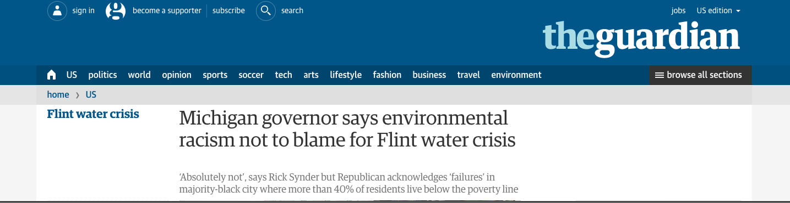

In an [interview](http://www.msnbc.com/morning-joe/watch/snyder-shrugs-off-environmental-racism-claims-606625859823) on MSNBC’s Morning Joe, the Republican governor acknowledged “major failures” on the part of the state’s government in addressing the lead contamination that has poisoned thousands of residents of Flint, Michigan, but strongly resisted charges that racism was one of those failures.

ADVERTISING

“I’ve made a focused effort since before I started in office to say we need to work hard to help people that have the greatest need,” Snyder said. “This was a terrible tragedy. These people work for me. And that’s why it was important to accept responsibility, and my focus is on fixing this problem.”

Although race and class are never mentioned in the 274 pages of emails related to Flint’s water crisis released earlier this week by Snyder’s office, Flint residents and civil rights advocates have linked the government’s slow response to the crisis to environmental racism, a term that refers to the [proven correlation](http://archive.gao.gov/d48t13/121648.pdf) between the racial, ethnic and class backgrounds of an area’s residents and proximity to hazardous waste. Flint is a majority-black city where more than [40% of residents](http://factfinder.census.gov/faces/nav/jsf/pages/community_facts.xhtml)live below the poverty line.

Instead, Snyder pinned the water crisis on failures by “quote-unquote experts” to provide regulatory agencies with “the right information”.

“That’s a huge bureaucratic problem, and it’s part of the problem with culture in government,” Snyder said. “This is something that we don’t consider just what one person did. Let’s look at the entire cultural background of how people have been operating. Let’s get in there and rebuild a culture that understands. Common sense needs to be part of it. Taking care of our citizens needs to be part of it. That’s [of] paramount importance when you’re talking about the safety of our citizens.”

Advertisement

Snyder’s assertion that state agencies were denied accurate information runs counter to the findings of the Flint Water Advisory Task Force, which released a [preliminary report](http://flintwaterstudy.org/wp-content/uploads/2015/12/FWATF-Snyder-Letter-12-29-15.pdf) in December 2015 laying ultimate blame for the water.

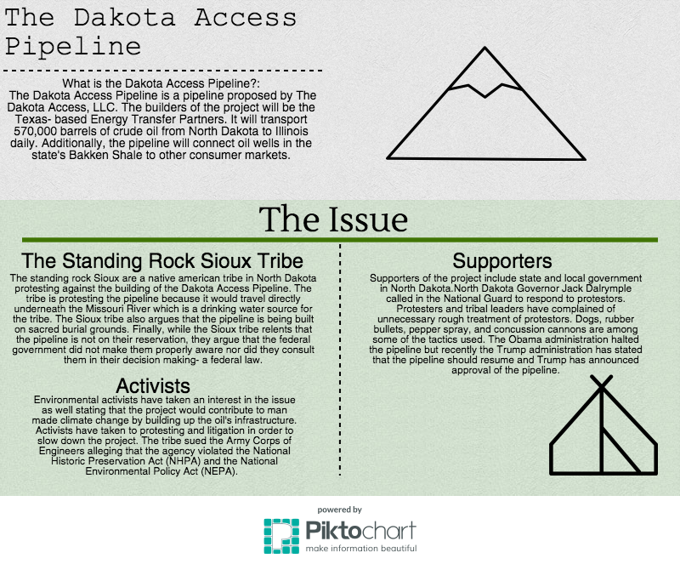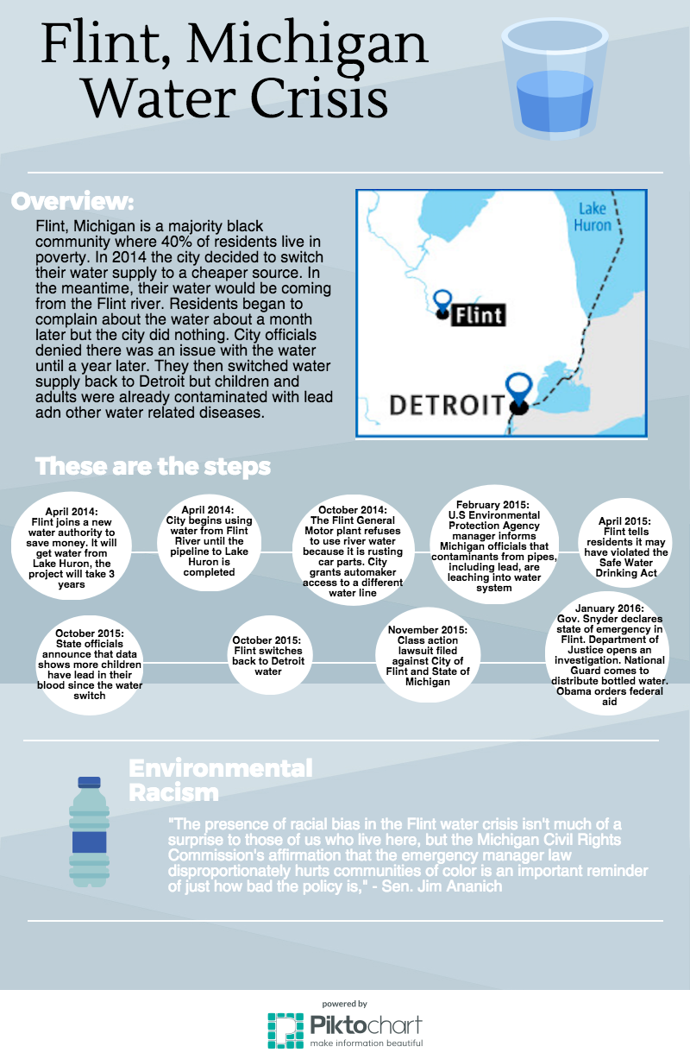

Clean Water: The Struggle for Environmental Justice in Flint and Standing Rock

Almasy, Steve, and Laura Ly. "'Systemic Racism' Cited in Flint Water Crisis." *CNN*. Cable

News Network, 18 Feb. 2017. Web.

This video is similar to an article I use later on which features a timeline of the flint water crisis. The video begins with explaining why the Flint government switched their water suppliers to the various problems found with the water from the river. The video goes on to discuss the deaths and diseases that occurred from the contaminated water. Then the video goes on to discuss the court proceedings and the lead levels found in the water of late. The video provides a good 90 second overview of the flint water crisis.

The video was featured with an article which went on to describe politics and racism involved in the Flint water crisis. The article discusses a report that states there were no specific violations of state civil right laws but that "historical, structural and systematic racism combined with implicit bias played a role in the problems." The article goes on to discuss other class action lawsuits that allege discrimination similar to the reports findings.

Bullard, Robert D. *The Quest for Environmental Justice: Human Rights and the Politics of*

*Pollution*. San Francisco: Sierra Club, 2008. **Print.**

This book discusses the acts that are in place, specifically in the United States, that are meant to protect against environmental racism. The book focused on specific instances of environmental racism taking place. To begin however, the book discussed the reasoning behind environmental justice and what it means in regards to the social justice fight, it also discussed the reasoning behind eliminating the threat of environmental defects before they come to be a problem. I focused primarily on the book's discussion of lead in houses that affects primarily black communities and the overall discrimination that black communities typically face at the hands of the government. The book also focused on the idea of zoning and how zoning disproportionately affects black communities. Looking specifically at neighborhood zoned garbage sites the book talked about Houston, Texas and it provided an easy to read chart that I will feature that showcases the landfill locations in Houston which primarily are placed in black communities with the exception of one landfill in a predominately white community. I will also use the book's discussion on Native Americans and the quiet discrimination that takes place in terms of taking resources from reservations, removing native Americans from reservations, and the implementation of environmental hazards in Native American lands.

*Environmental Justice, Explained*.  Grist, 26 Jan. 2016.Web.

This video begins with looking at the bigger picture- a city and then looking closely at the inhabitants in the city. It explains that cities are typically broken up by race and that this disproportionately affects the way the inhabitants of a city live. Without explaining who is who, the video states that some parts of the cities are given grocery stores with fresh produce and organic options while other parts of the cities are riddled with landfills and pollution. The video then begins explaining where this unequal treatment of city zones began- racial discrimination. The video then goes on to explain that while the city attempts to ‘fix’ the problem it only benefits the parts of the cities where the wealthier, white citizens reside. Finally, the video touches on the reality of the environmental justice and that the city outlined in the video is an accurate portrayal of cities in America based on race, income, and ethnicity ending with the effects this has on those who live in poor communities. The video ends with explaining that environmental justice means working towards equaling the playing field and social justice as an environmental issue.

*Environmental Racism Explained.* Perf. Dena Takruri*.* AJ+, 29 Jan. 2016. Web.

This video opens up with images of land pollution and the racism that exists in our land and water. The video has a quote from an environmental scientist explaining environmental racism in the United States. The video goes on to examine Flint, Michigan and the environmental racism occurring in the city. The video explains what happened in Flint, Michigan and how it explains other environmental racism that occurs in poverty stricken communities that mostly consist of black citizens. Next the video outlines Detroit, Michigan and the effects of environmental racism in the city. The video points out cases of asthma in kids that exist in nearby cities due to air pollution. The video highlights cancer alley in Louisiana and the black residents that are affected in this community. Finally, the video discusses the EPA and the office of civil rights which is supposed to keep track of environmental racism in the United States. However, the video points out this is not the case and the office rejects 90% of the cases that are filed.

Kennedy, Merrit. "Lead-Laced Water In Flint: A Step-By-Step Look At The Makings Of A

Crisis." *NPR*. NPR, 20 Apr. 2016. **Web.**

This article provides a comprehensive overview from the start of the Flint Michigan crisis to where we are now. The article begins with a brief synopsis that talks about what the crisis is. It also explains that Flint is a majority black city where 40 percent of the population is in poverty. The article starts with June 2012- April 2013 where the city of Flint began to look for cheaper water. The city was currently using the Detroit Water and Sewage department (DWDS). They then decided to build a pipeline to connect to the Karegnondi Water Authority (KWA) which would save them $200 million over 25 years. The Flint emergency manger told the state treasurer that it would be joining the KWA and a day later the DWSD tells the manager that it will terminate service to the city effective a year later. (April 2014). This is what causes the city to switch to the Flint river while waiting for the pipeline to be operational. The article then goes on to detail each bacterium that was found in the water until lead is found. From there the article outlines the wrong doings on the part of the government and the various stages that are taken by the mayor, governor, and president. The article then finishes with the criminal charges and the court case that occurred during the water crisis.

Loftus, Alex, and Farhana Sultana. *The Right to Water: Politics, Governance and Social*

*Struggles*. London: Earthscan, 2012. **Print.**

**The book dealt primarily with the governance of water and the issue of privatization of water. Additionally, the book outlined the various laws and resolutions that dealt with water and how it affects the governance of water on a larger scale. The book discussed those who are disproportionately and adversely affected by access to water or lack thereof. There was significant attention given to General Comment No 15 due to its regards towards the many uses of water and how water access should be distributed. The book also focused on the argument of quantity of water versus being involved in the discussion of water. In other words, the book was interested in whether it was enough to say that everyone should, for example, be given 50 liters of water or whether including citizens in the discussions of their water would benefit those without access to water. In discussing privatization the book touched on how this affects those who cannot afford water and the ways companies tend to disregard poverty stricken communities which in turn, results in these communites not having access to water in their homes.**

Meyer, Robinson. "The Legal Case for Blocking the Dakota Access Pipeline." *The Atlantic*.

Atlantic Media Company, 09 Sept. 2016. **Web.**

This article provides the legal framework for the Dakota Access Pipeline case and explains the court proceedings in an easy to read format. The article begins with where the pipeline will be built- it will stretch more than 1,100 miles from oil fields in North Dakota to a river port in Illinois. At this point the article discuss the Standing Rock tribe’s opposition to the pipeline- the pipeline could threaten their sole water source, they were not consulted before the pipeline was approved, and the pipeline will pass through and destroy Native burial sites and sacred places. The article goes on to explain that some concerns of the pipeline focus on climate change. It details why climate activists are against the Dakota Access Pipeline stating they are striving to block the extraction of fossil fuels in order to prevent carbon emissions. The article goes furhter to examine the argument of ‘whose land it is’ and the history of the Sioux tribe and government dealings/ treaties established with them. What makes the article interesting is that it veers away from solely examining the issue as a climate activist but towards the mistreatment of native American tribes, the governments handlings of the tribes, and the upholding’s of prior decrees.

Winkler, Inga. *The Human Right to Water: Significance, Legal Status and Implications for Water*

*Allocation*. N.p.: Hart, 2002. **Print.**

**The book opens up with a broad discussion of the issues that occur when citizens are not given access to water. It goes over the diseases that are water born and water washed in order to draw the conclusion that clean water is a necessity. Then, the book goes on to explain that water as a human right was not recognized officially until 2010. It discusses that the human right to water was not a big issue in the 1950s-1960s when the UN was drafting resolutions that would have pertained to the human right to water. Going forward the book outlines the various resolutions and laws that were implemented in regards to water and the adequate standard of living argument. The book then deals with the argument of whether water as a human right is a branch of the adequate standard of living. The book shows the two arguments and details if water was previously included in the adequate standard of living law or if a law solely focusing on water was necessary. It also discusses water as a governmental issue. The right to life argument is discussed and the relation to water in terms of hygiene, cooking, agriculture, and drinking.**

Worland, Justin. "Dakota Access Pipeline: What to Know About the Controversy." *Time*. Time,

26 Oct. 2016. **Web.**

**This article offers a comprehensive review of the entire Dakota Access Pipeline controversy. The article starts out by explaining what the Dakota Access Pipeline is and includes the cost and where it will be built. Moving on the article explains why the Sioux and others are protesting the pipeline. The article focuses on the Sioux tribe as well as what environmental activists are saying about the project. The article moves on to focus on what the various opponents of the pipeline have to say about the project and what supporters of the project respond with. The article discusses the response of the federal government and the response of the then two presidential candidate.. Finally, the article sums up with a paragraph on the relation to the Keystone XL pipeline.**